Model: BC-DTS150-10

150W DC-10GHz RF Attenuator
Coaxial fixed attenuators are used in absorbing energy of transmission line, expanding power range and controlling power level, they are also used in accurately measuring power or spectrum of RF microwave transmitters accompany with small power meter, comprehensive tester or spectrum analyzer.
Technical Data Sheet
Frequency Range | DC~10GHz
Connectors | N,7/16 (DC-4GHz)
Body Material and Plating | Aluminum, Black Anodize
Power | 150W
Peak Power | 5KW ((5μs pulse width, 3% duty circle )
Impedance | 50Ω
Temperature Range | -55°C～+125°C
Dimensions | A:173×130×75mm; B:173×78×78mm; E2: 85×86×173mm
Weight | A:1.5Kg; B:1.5Kg; E2:1.5Kg
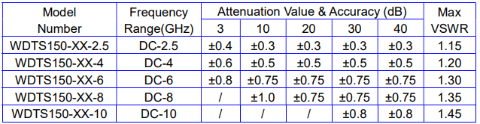
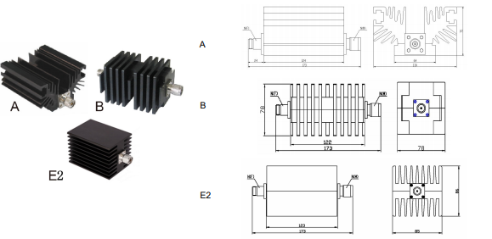
Tolerance：±5%

